**STOCK PRICE PREDICTION USING TIME-SERIES ANALYSIS**

Abhinav

B.Tech Fourth Year

Department of Computer Science

Inderprastha Engineering College

Ghaziabad, Sahibabad India

[abhinavch@gmail.com](mailto:abhinavch@gmail.com)

Anshika Gupta

B.Tech Fourth Year

Department of Computer Science

Inderprastha Engineering College

Ghaziabad, Sahibabad India

[anshika.04@outlook.com](mailto:anshika.04@outlook.com)

Shivani Sharma

Assistant Professor

Department of Data Science

Inderprastha Engineering College Ghaziabad, Sahibabad India

[shivani.sharma@ipec.org.in](mailto:shivani.sharma@ipec.org.in)

Ashutosh Kumar

B.Tech Fourth Year

Department of Computer Science

Inderprastha Engineering College

Ghaziabad, Sahibabad India

[ashutoshkumar.15@outlook.com](mailto:ashutoshkumar.15@outlook.com)

***Abstract*— In Stock Market Prediction, the point is to foresee the future worth of the monetary loads of an organization. The new pattern in securities exchange forecast advancements is the utilization of AI which makes expectations dependent on the upsides of current securities exchange records via preparing on their past qualities. AI itself utilizes various models to make forecast simpler and credible.**

**This project aims to predict the future value of the financial stocks of the companies and aid the beginner to start their journey in Trading in an informed manner, also providing insights about the stocks to the intermediate and expert traders so that they can also make informed decision.**

**In the project we will be gathering enormous amount of data from the past and try to predict the Future value of the Stock using “Time-series” Analysis, whilst that will be the major guiding parameter for our system, this system will try to gather market emotions through various platforms like Twitter, Journals, News etc. to understand how the stock must be affected and variate the obtained value based on that.**

***Keywords— Machine Learning Algorithm, Stock Price prediction, time series analysis.***

**1. INTRODUCTION**

As the market is developing, an ever-increasing number of individuals are seeing how their cash ought not be resting, while the entire market is going up with expansion, and putting away their cash to the supplies of organization and developing their portfolio has turned into a pattern and a brilliant decision also.

We see everyday new traders join in the trading world, and everyday many of them quit as they faced a huge loss in their first investment. This arises a default question, WHY? Why new investors generally go into loss while the market is always growing? The answer to this question is also very basic, “Un-informed decision” and “Gut-based Decision”. People who tend to use Vodafone-idea will think that the product that they use and like should also grow as it goes, but that is not the cases in the market and thus they start to see their money going in-vain from the very next day of their journey in investment and trading.

Stock prediction system is a system which will assist these beginners to begin their journey based on an informed decision, allowing them more room to learn and grow whilst the decisions are not merely based on gut, but speaking practically, is this problem only faced by beginner? NO! they also face the same problem, and they surely can’t predict the sudden hikes all by noticing a few tweets, and it is impossible for even Experienced investors to see how suddenly things go to the upside or downside. Our system will help these seasoned investors to see what might happen and make decision based on that.

We use the simple procedure for forecasting time series data based on an additive model where non-linear trends are fit with yearly, weekly, and daily seasonality, plus holiday effects.

**2. LITERATURE REVIEW**

Jasic and Wood (2004) developed an artificial neural network to predict daily stock market index returns using data from several global stock markets. The focus is on trying to support profitable trading. A method is introduced based on univariate neural networks using untransformed data inputs to provide short-term stock market index return predictions. The study uses the daily closing values of the Standard and Poor’s 500 Index (S&P 500), the German DAX Index, the Japanese TOPIX index, and London’s Financial Times Stock Exchange Index (FTSE All Share). The samples for the S&P 500, DAX and FTSE Index are from January 1, 1965 to November 11, 1999. The sample for TOPIX covers the period from January 1, 1969 to November 11, 1999 since data from earlier years was not available. The prediction performance for the neural network is evaluated against a benchmark linear autoregressive model and prediction improvement is confirmed when applied to the S&P 500 and DAX indices.

The prediction performance for the neural network is evaluated against a benchmark linear autoregressive model and prediction improvement is confirmed when applied to the S&P 500 and DAX indices.

Liao and wang presumed that investors choose their investment positions by analyzing historical stock market data, and the historical data are given weights based on how near they are to the present.

The nearer the historical data time is to the present, the stronger the impact the data have on the predictive model. The model’s effectiveness is analyzed using a numerical experiment based on data from each trading day in an 18-year period from December 19, 1990 to June 7, 2008.

The data is from several stock markets including the Shanghai and Shenzhen Stock Exchange Stock A Index (SAI), Stock B Index (SBI), and the Hang Seng (HIS), Dow Jones Industrial Average (DJIA), NASDAQ Composite (IXIC) and S&P500.

The forecasting performance of the model is assessed using various volatility parameters.

Chong, Han and Park analyzed deep learning networks for stock market analysis and prediction. Deep learning networks extract features from a large set of raw data without relying on prior knowledge of predictors which makes it useful for high frequency stock market prediction.

They provide an objective assessment of both the advantages and drawbacks of deep learning algorithms for stock market analysis and prediction.

Using high-frequency intraday stock returns as input data, they examine the effects of three unsupervised feature extraction methods—principal component analysis, autoencoder, and the restricted Boltzmann machine—on the network’s overall ability to predict future market behavior.

Testing is done using data from 38 companies listed in the Korean KOSPI stock market from the period January 4, 2010 through December 30, 2014.

**3. PROPOSED METHODOLOGY**

We utilize a decomposable time series model (Harvey and Peters 1990) with three fundamental model parts: pattern, irregularity, and occasions. They are consolidated in the accompanying condition:

Y(t) =g(t) +s(t) +h(t) +Et

Here g(t) is the pattern work which models non-intermittent changes in the worth of the time series, s(t) addresses occasional changes (e.g., week by week and yearly irregularity), and h(t) addresses the impacts of occasions which happen on conceivably sporadic timetables more than at least one days. The error term Et addresses any peculiar changes which are not obliged by the model; later we will make the parametric suspicion that Et is ordinarily circulated. This particular is like a summed up added substance model (GAM) (Hastie and Tibshirani 1987), a class of relapse models with conceivably non-direct smoothers applied to the regressors. Here we utilize just time as a regressor yet perhaps a few direct and non-straight elements of time as parts. Demonstrating irregularity as an added substance part is a similar methodology taken by dramatic smoothing (Gardner 1985). Multiplicative irregularity, where the occasional impact is a variable that duplicates g(t), can be cultivated through a log change. The GAM plan enjoys the benefit that it deteriorates effectively and obliges new parts as essential, for example when another wellspring of irregularity is recognized. GAMs additionally t rapidly, either utilizing backfitting or L-BFGS (Byrd et al. 1995) (we favor the last option) so the client can intelligently change the model boundaries. We are, basically, outlining the guaging issue as a bend fitting activity, which is innately not the same as time series models that unequivocally represent the fleeting reliance structure in the information. While we surrender some significant inferential benefits of utilizing a generative model, for example, an ARIMA, this plan gives various commonsense advantages: {Flexibility: We can without much of a stretch oblige irregularity with numerous periods and let the investigator make various presumptions about patterns.

**3.1 Seasonality**

Business time series regularly have multi-period irregularity because of the human practices they address. For example, a 5-day work week can deliver results on a period series that recurrent every week, while get-away timetables and school breaks can create outcomes that recurrent every year. To t and gauge these effects we should determine irregularity models that are intermittent elements of t. We depend on Fourier series to give an adaptable model of occasional effects (Harvey & Shephard 1993). Leave P alone the customary period we anticipate that the time series should have (for example P= 365:25 for yearly information or P= 7 for week after week information, when we scale our time variable in days). We can inexact discretionary smooth occasional effects.

**3.2 Holidays and Events**

Holidays and events give enormous, unsurprising shocks to numerous business timeseries and frequently don't follow an intermittent example, so their effects are not all around demonstrated by a smooth cycle. For example, Thanksgiving in the United States happens on the fourth Thursday in November. The Super Bowl, one of the biggest broadcast occasions in the US, happens on a Sunday in January or February that is hard to announce automatically. Numerous nations all over the planet have significant occasions that follow the lunar schedule. The effect of a specific occasion on the time series is regularly comparative a seemingly endless amount of many years, so it is essential to consolidate it into the estimate.

**4. TIME-SERIES ALGORITHMS**

Time series is a sequence of main data points in chronological sequence, frequently accumulated in normal spans. Time series analysis can be applied to any factor that changes over the long run and as a rule, typically information focuses that are nearer together are more comparative than those further separated.

Regularly, the parts of time series information will incorporate a trend, seasonality, noise or randomness, a curve, and the level.

Level: When you read about the “level” or the “level index” of time series data, it’s referring to the mean of the series.

Noise: All time-series data will have noise or randomness in the data points that aren’t correlated with any explained trends. Noise is unsystematic and is short term.

Seasonality: If there are regular and predictable fluctuations in the series that are correlated with the calendar – could be quarterly, weekly, or even days of the week, then the series includes a seasonality component. It’s important to note that seasonality is domain specific, for example real estate sales are usually higher in the summer months versus the winter months while regular retail usually peaks during the end of the year. Also, not all time series have a seasonal component, as mentioned for audio or video data.

Trend: When referring to the “trend” in time series data, it means that the data has a long-term trajectory which can either be trending in the positive or negative direction. An example of a trend would be a long-term increase in a company’s sales data or network usage.

Cycle: Repeating periods that are not related to the calendar. This includes business cycles such as economic downturns or expansions or salmon run cycles, or even audio files which have cycles, but aren’t related to the calendar in the weekly, monthly, or yearly sense.

**5. PROPOSED SYSTEM**

The suggested solution consists of two key components: 1) a web-based application and 2) a machine learning-based stock prediction system.

The web-application will allow the user to engage with the model and select the stock that they need to see the prediction for, the model itself will collect the raw-data for the time-series analysis apply various filters to it and then come with the given number of days predicted.

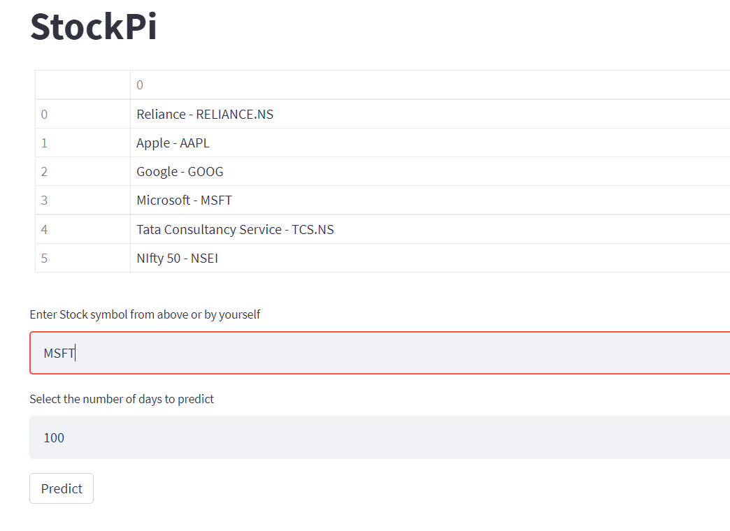

**7. RESULT**

The Stock price prediction uses the time-series analysis with trends and business in the considerations and predicts the future value of the stock closing price in the future. Machine Learning can be a great asset when it comes to solving problems which require speculations although if we need to predict something based on data, Machine learning is the most preferred way of doing so.

Our model is able to create a Simple Moving Average and then able to predict the future values of stock price and give us output so that we can take a informed decision.

**VII. CONCLUSION**

The major goal of this paper is to predict the values of the stock price of various companies and stock listings by the historical data available. The future scope of this paper is (not limited to): How can we understand the effect of market emotions to the stock price and add it’s affect to our analysis and in turn making a model which also checks for the current news, articles, tweets and social media posts and balance the affect in its predictions as well.

We've also built a user-friendly graphical user interface (GUI) to let users engage with the system more effectively. This study demonstrates how a Machine Learning algorithm can be used to easily predict stock price using various factors and models. At the end of the day, we can say that our system has no user threshold because anyone can use it.

**8. REFERENCES**

[1]. Teo Jašić, Douglas Wood: The profitability of daily stock market indices trades based on neural network predictions: case study for the S&P 500, the DAX, the TOPIX and the FTSE in the period 1965-1999. Applied Financial Economics, 2004, vol. 14, issue 4, 285-297.

[2]. Zhe Liao, Jun Wang: Forecasting model of global stock index by stochastic time effective neural network. Expert Systems with Applications, Volume 37, Issue 1, January 2010, Pages 834-841.

[3]. Eunsuk Chong, Chulwoo Han, Frank C. Park: Deep learning networks for stock market analysis and prediction: Methodology, data representations, and case studies. Expert Systems with Applications, Volume 83, 15 October 2017, Pages 187-205.

[4]. Taylor SJ, Letham B. 2017. Forecasting at scale.

[5]. Aparna Nayak, M. M. Manohara Pai, Radhika M. Pai, Prediction Models for Indian Stock Market, Procedia Computer Science, Volume 89, 2016, Pages 441-449, ISSN 1877-0509.

[6]. Patil, Rajat. (2021). Time Series Analysis and Stock Price Forecasting using Machine Learning Techniques. 19. 10.1994/Rajat/AI.

[7]. Mehtab, Sidra & Sen, Jaydip. (2020). A Time Series Analysis-Based Stock Price Prediction Framework Using Machine Learning and Deep Learning Models.